The post conference tour of the UEAA in the region of Champagne; Biorefinery and Cellars of Champagne – A votre santé – 13 October 2016.
-

In the aftermath of the UEAA Paris meetings 11- 12 October 2016, twenty members of the UEAA from various countries, accompanied by some members of the Academy of Agriculture of France, took part in a tour of the biorefinery Bazancourt-Pomacle located 15 km north of Reims (France).

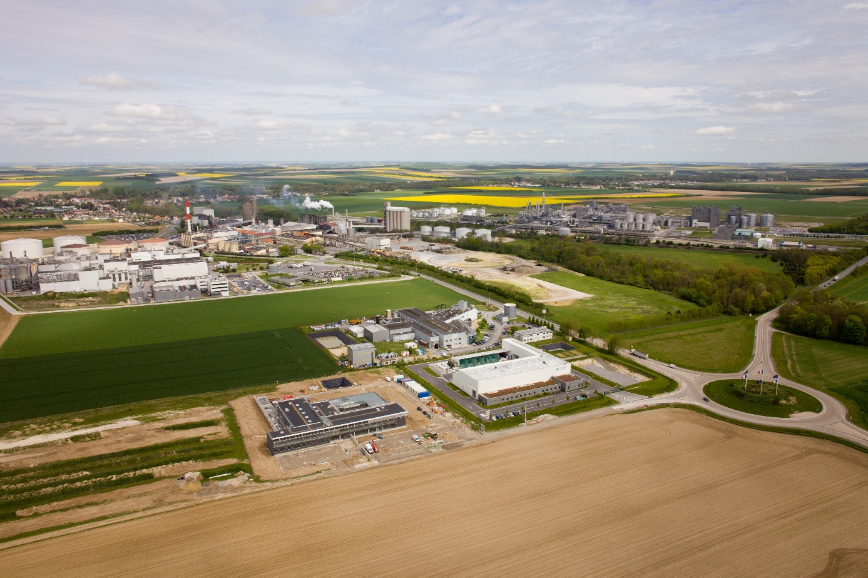

This biorefinery is dedicated to the transformation and development of local agricultural resources in a context of circular economy in order to share the best resources between different actors and enhance optimally all plant components. Production is mainly dedicated to food. Co-products of this first stage is transformed into a wide range of bio-based products replacing non-renewable fossil materials or adding new features, to supply multiple markets.
Around three agro-industrial units (a starch processing 400,000 t / year of corn, a sugar beet crushing 23 000 t / d of beet during a 100-day campaign, and a distillery producing 3 million hl / year of alcohol and ethanol from wheat and beetroot) several research laboratories associated with engineering schools and universities, pre-industrial pilot, contribute to the development of new processes, including the extraction and recovery of new molecules for plant chemistry.
Greeted at CEBB (European Center for Biotechnology and Bioeconomy - http://www.agroparistech.fr/+Inauguration-du-Centre-Europeen-de+.html), which includes the chairs of colleges and universities, in order to get an overview of the site, members UEAA could then visit:
- FUTUROL, which aims to develop and market a complete process of second generation bioethanol production. This project is remarkable for its multi-resource approach, that is to say the use of diverse materials: whole plants, wood, residues and co-products. www.projetfuturol.com
- ARD (Agro-industry Research and Development), which is a shared private research organization that develops skills in:
• fractionation plant and refinery,
• white biotechnology (industrial)
• plant chemistry and agro-materials,
• the environment.
ARD has nearly 130 employees. www.a-r-d.fr
- CRISTANOL is a leading European bioethanol production. Subsidiary of Cristal Union (majority shareholder) and Blétanol (union of French cereal cooperatives). CRISTANOL represents an investment of 270 million euros for a production capacity of 280 000 tonnes of ethanol, based on beets and wheat.
Staff: more than 130 people
www.cristal-union.fr/sites-de-production/distillerie-cristanol/
The day ended with a tour of a Champagne cellar in Reims, with tasting, in friendliness and good humor.

